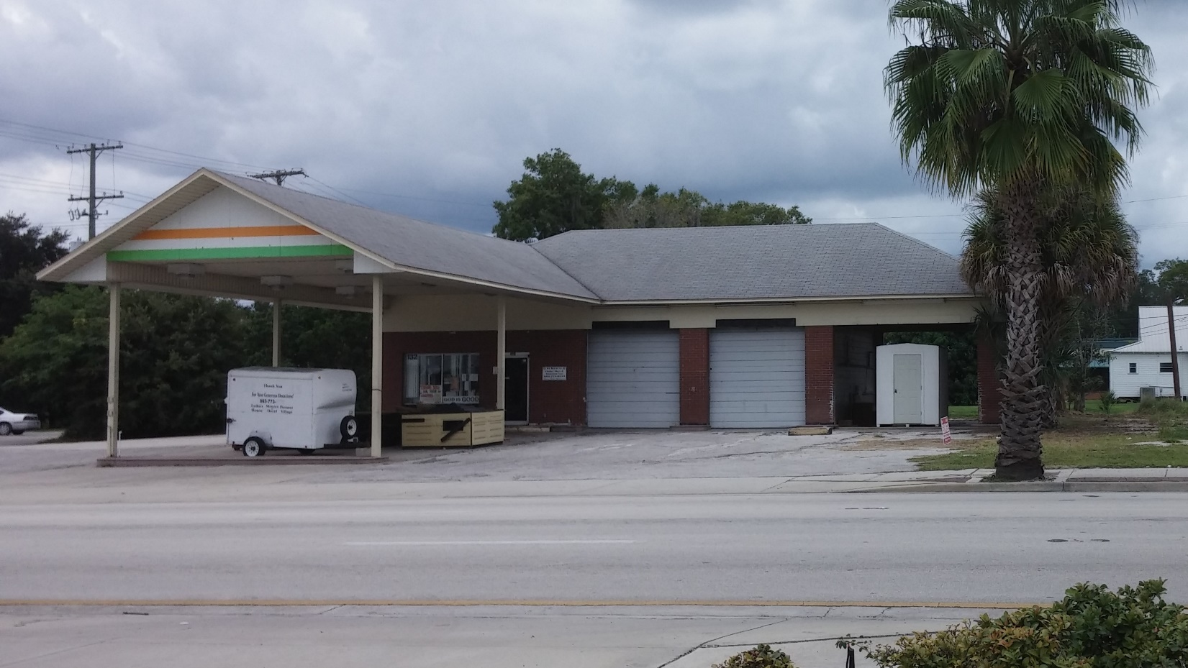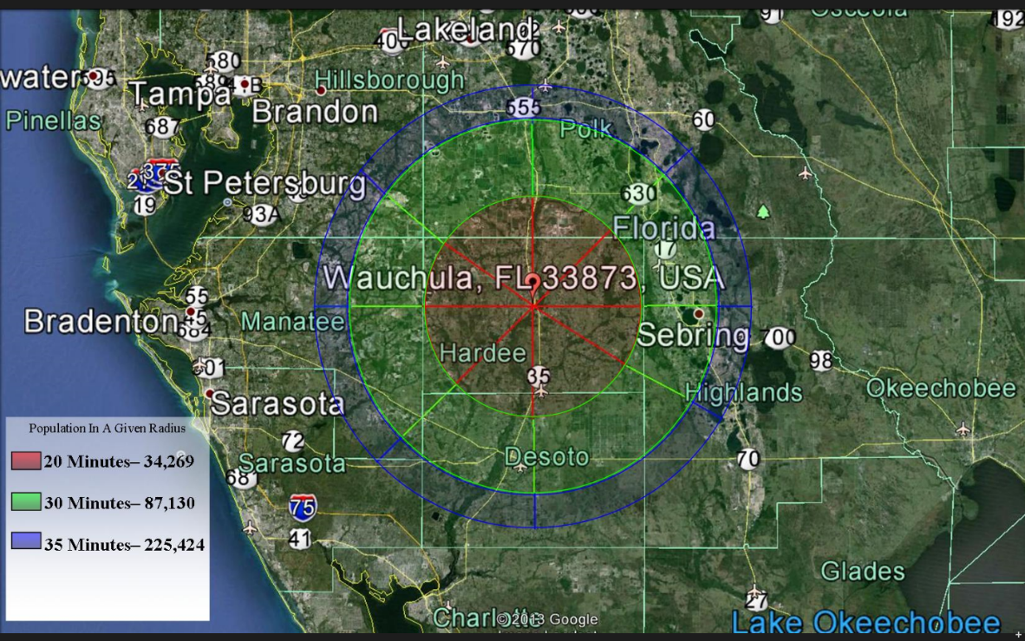

* LEASE PRICE $1,000 + tax monthly
* PURCHASE PRICE $229,000 - negotiable
* BUILDING .395 acres (property size) 1,950 sf (building size)
* YEAR BUILT 1971
* ZONING HC1 – Historic Commercial
* TAXES $2,825.82 (2015)
* AADT 9,100 (Annual Average Daily Traffic – FDOT 2012)
* Contact Glenn Wright – (863) 602-7952

Community Redevelopment Agency: (863) 767-0330; jnewman@cityofwauchula.com

132 S. 6th Avenue, Wauchula, FL 33873

The City of Wauchula serves as the county seat for Hardee County, located in south central Florida. The general population of the county served by the commercial hubs of Bowling Green, Wauchula, and Zolfo Springs is approximately 28,000 citizens. There are 9,500 households and approximately 1,300 commercial business entities located in this 637 square mile area.